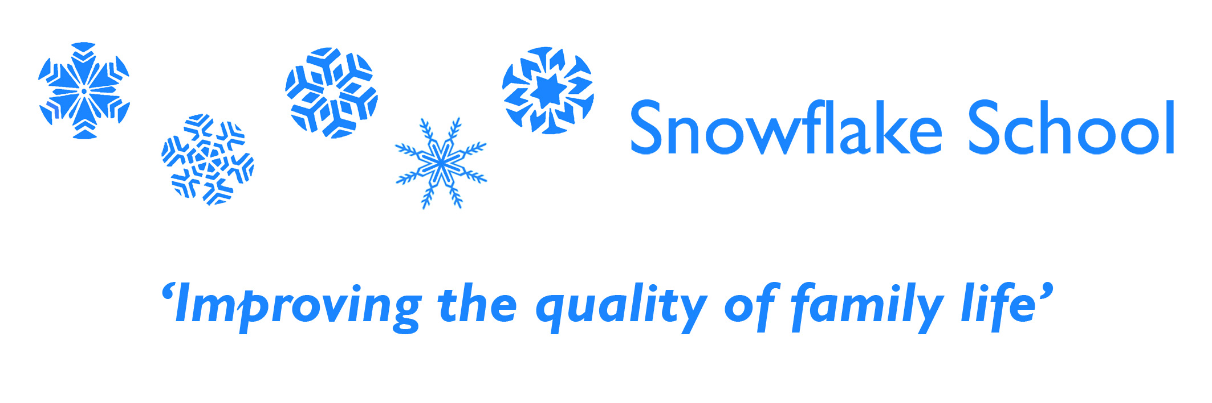
Tutor Person Specification

E: ‘essential’ to applicants. D: ‘desirable’ to applicants

- Degree and/or a minimum of one year ABA/VB experience.  - Additional qualifications within a relevant field of study.  - Experience of working with children.  - Experience of working with children with Autism in an educational setting  - Good observational skills  - Good spoken English and understanding of English.  - Good organisational skills.  - Excellent communication skills.  - Excellent record of attendance and timekeeping skills.  - The ability to work as part of a team.  - Have high regard for pupils, treating each with dignity and respect.  - Good general health and emotional resilience.  - Ability to support children that have challenging behaviour.  - Ability to engage children with communication difficulties.  - Use initiative and have the ability to follow through on tasks.  - To have respect for the confidential nature of pupil information.  - Willingness to participate in educational activities outside of the school setting.  - Awareness of health and safety.  - Ability to record and analyse data.  - A proven ability to demonstrate awareness of the principles of and commitment to the promotion of the equality of access and opportunity for children, to overcome obstacles/barriers to this and to remove practices which are counter to it. | D  D  E  D  E  E  E  E  E  E  E  E  E  E  E  E  E  E  E  E

